

|  |
| --- |
| CS 1103 - FR02B  Assignment 6 |
| By Ngoc Phuong Anh Nguyen - 3712361  March 2021 |

# Chapter Eight Questions:

## Create a table in your MySQL/MariaDB account, Schools:

/* Copy and paste this code to create the table */

DROP TABLE IF EXISTS schools;

CREATE TABLE Schools

(

schoolId INT NOT NULL AUTO_INCREMENT,

name varchar(50) NOT NULL,

province varchar(20) DEFAULT NULL,

language char(2) DEFAULT NULL,

level varchar(10) DEFAULT NULL,

PRIMARY KEY (schoolId)

);

## Create and test three types of SQL statements. Show your work from the command line (i.e. correct command and result).

### Create a new School record. Add several records to the table and read all School records.

#### Source code:

INSERT INTO Schools(name, province, language, level)

VALUES

(

'Westisle Composite High School','Prince Edward Island','EN','High'

),

(

'Yarmouth Consolidated High School','Nova Scotia','EN','High'

),

(

'École Grande Rivière Secondary School','New Brunswick','FR','High'

),

(

'École Marie-Gaétane High School','New Brunswick','FR','High'

),

(

'Cambridge Narrows Community School','New Brunswick','EN','High'

),

(

'Houlton High School ','Maine','EN','High'

);

SELECT * FROM Schools;

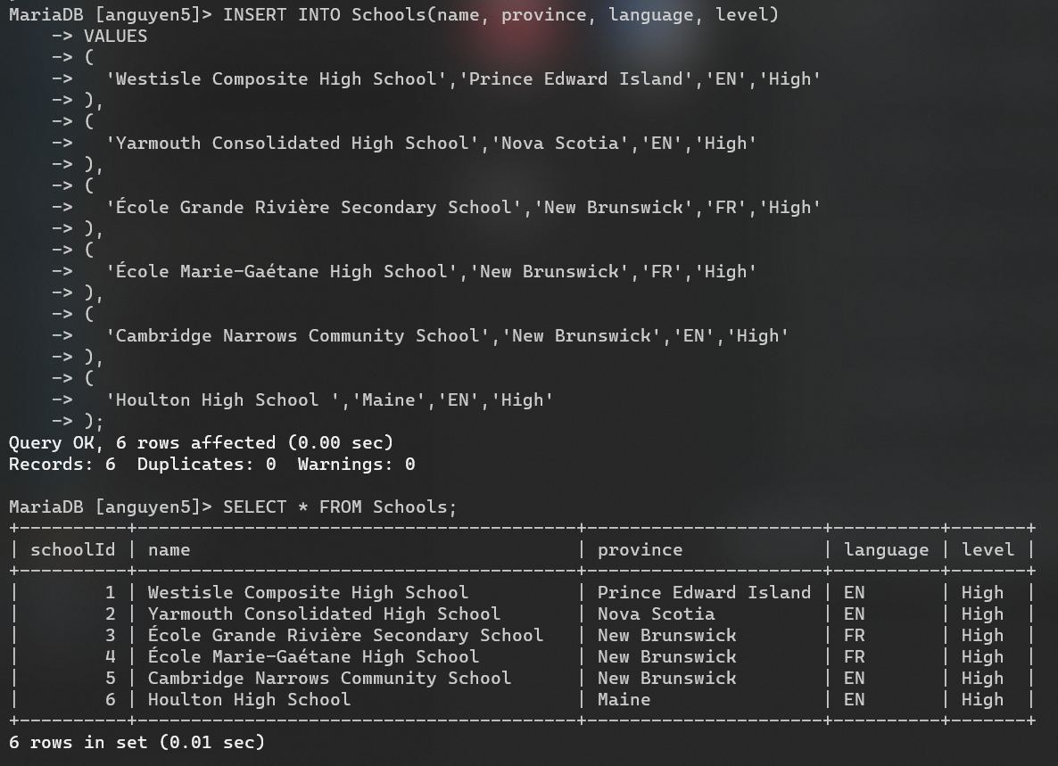

Figure 1: Command Line and Result in the Terminal (Sreenshot)

### For the School record with a schoolId of 2, update the province to ‘Manitoba’. Read all School records

#### Source code:

UPDATE Schools

SET province = 'Manitoba'

WHERE schoolId = 2;

SELECT * FROM Schools;

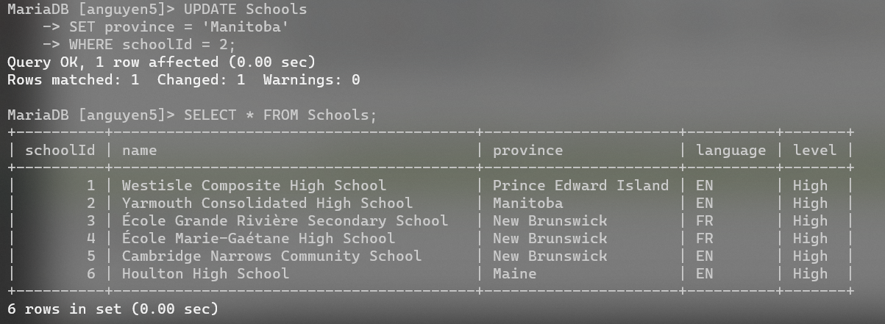

Figure 2: Command Line and Result in the Terminal (Sreenshot)

### Delete the record whose province value is ‘Manitoba’. Read all School records

#### Source code:

DELETE FROM Schools

WHERE schoolId = 2;

SELECT * FROM Schools;

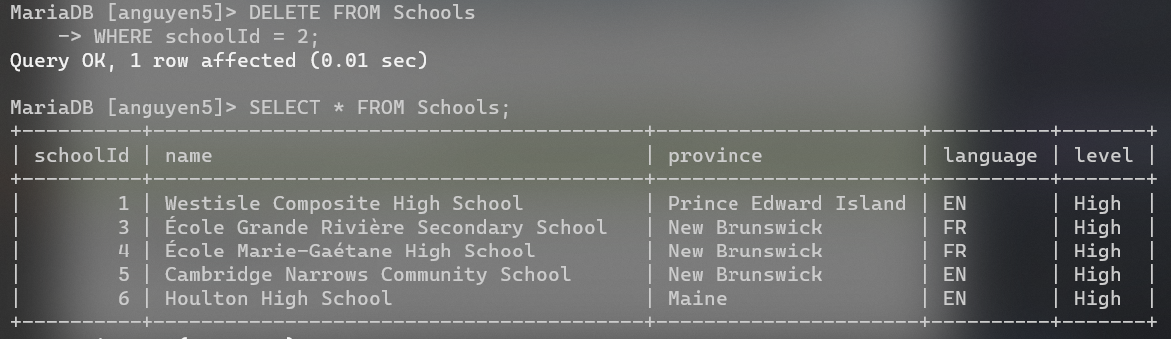

Figure 3: Command Line and Result in the Terminal (Sreenshot)

# Chapter Nine Questions:

## Question 1: The ABC Car Service & Repair Centers are owned by the Silent Car Dealership; ABC services and repairs only silent cars. Three ABC centers provide service and repair for the entire state.

## Each of the three centers is independently managed and operated by a shop manager, a receptionist, and at least eight mechanics. Each center maintains a fully stocked parts inventory.

## Each center also maintains a manual file system in which each car’s maintenance history is kept: repairs made, parts used, costs, service dates, owner, and so on. Files are also kept to track inventory, purchasing, billing, employees’ hours, and payroll.

## You have been contacted by one of the center’s managers to design and implement a computerized database system. Given the preceding information, do the following:

### Indicate the most appropriate sequence of activities by labeling each of the following steps in the correct order. (e.g., if you think that “Load the database” is the appropriate first step, label it “1.”)

|  |  |
| --- | --- |
| **Step** | **Activities** |
| 7 | Normalize the conceptual model. |
| 3 | Obtain a general description of company operations. |
| 9 | Load the database. |
| 4 | Create a description of each system process. |
| 11 | Test the system. |
| 6 | Draw a data flow diagram and system flowcharts. |
| 5 | Create a conceptual model using ER diagrams. |
| 10 | Create the application programs. |
| 2 | Interview the mechanics. |
| 8 | Create the file (table) structures. |
| 1 | Interview the shop manager. |

Figure 4: Activities with correct order.

### Describe the various modules that you believe the system should include.

There are 4 main modules that the system should include, and each of them include some sub-modules:

* Inventory: maintains a fully stocked parts inventory of the system.
  + Parts: are used/maintained/purchased.
  + Purchasing records: hold the purchase history.
* Payroll: keeps information of employees and the amount of money they have to be paid.
  + Payroll of the employees: the employees’ playroll are processed.
* Work order: etailed information of the work order.
  + Maintenance: records the histories of maintenance.
  + Work order: Maintenance histories that are made to the card are recorded.
* Customer: maintains payments and receipts of the work order.
  + Billing: tracks the bill of the work order.
  + Payment: records the payments received.

### How will a data dictionary help you develop the system? Give examples.

The usage of data dictionary in the development of the system:

* They ensure the contents of the data dictionary provide consistency across the modules that are developed.
* They are used to evaluate the ability of the system and generating the reports that are required.
* They validate the relationship that is represented.
* They validate the support of the attributes in the report generation.

**Example:**

The data that are created needs to be used in a proper way, the billing system utilizes the records of the payment and receipt of the customer and this type of data ensures a proper report generation is made for the history of maintenance along with their payment and receipt history.

### What general (system) recommendations might you make to the shop manager? For example, if the system will be integrated, what modules will be integrated? What benefits would be derived from such an integrated system? Include several general recommendations.

### What is the best approach to conceptual database design? Why?

The best approach to conceptual database design would be centralized and top-down approach.

### Name and describe at least four reports the system should have. Explain their use. Who will use those reports?

1. **Monthly activity report:** contains the summary of service in the month and is classified by branch. It shows as a base for forecasting personnel and maintains the stock requirements for each branch and period.
2. **Customers activity report:** contains the summary of the activities of customers based on location, time, current balances, available credits, and so on. Demand-based service can be provided by forcasting promotional mails about the maintenance schedule as remainder and special kind of requirements is also provided based on the needs of the customer.
3. **Monthly inventory report:** contains the summary of inventory. The information should be about the vendors who will provide the parts to be reordered. This report will be especially useful for inventory management purposes.
4. **Mechanic Summary Sheet:** contains a summary of work hours clocked by each mechanic. This report would be generated weekly and would be useful for payroll and maintenance personnel scheduling purposes.

# Chapter Ten Questions:

## Question 13: What does this statement mean: “The web is a stateless system.” What implications does a stateless system have for database application developers?

The statement means that the HTTP protocol does not have built-in features to link a request to earlier requests and see them as part of the same (database) transaction.

## Question 16: What is XML, and why is it important?

XML is “Extensible Markup Language” - A meta-language used to represent and manipulate data elements.

XML allows the flexible development of user-defined document types. It provides a robust, non-proprietary, persistent, and verifiable file format for the storage and transmission of text and data both on and off the Web; and it removes the more complex options of SGML, making it easier to program for.

## Question 18: What are XML schema definition (XSD) documents, and what do they do?

XML schema definition documents are files contain the descriptions of an XML document.

These files use a syntax that resembles an XML document.

## Question 19: What is JDBC, and what is it used for?

IDBC is “Java Database Connectivity” - An application programming interface that allows a Java program to interact with a wide range of data sources, including relational databases, tabular data sources, spreadsheets, and text files.

JDBC is used for making a Java program to establish a connection with a data source, prepare and send the SQL code to the database server, and process the result set.